***NAME : Himanshu Dixit***

***ENROLL NO. : B64178***

***BATCH : B10***

***SOFTWARE DEVELOPMENT FUNDAMENTAL LAB-I(15B17CI171) Assignment Sheet (WEEK-12 PHASE-2)***

***Lab B***

***1.***[*Write a C program to copy contents from one file to another file.*](https://codeforwin.org/2018/02/c-program-to-copy-file.html)

**Solution:**

#include<stdio.h>

#include<stdlib.h>

int main()

{

char a[100],b[100],ch=' ';

FILE *fp;

fp=fopen("xyz.text","w");

if(fp==NULL){

printf("Error in opening file!");

exit(1);

}

printf("Input a sentence for the file xyz.text: ");

gets(a);

fprintf(fp,"%s",a);

fclose(fp);

printf("The file xyz.text created successfully");

fflush(stdin);

FILE *fp1;

fp1=fopen("mno.text","w");

if(fp1==NULL){

printf("Error in opening file!");

exit(1);

}

printf("\nInput a sentence for the file mno.text: ");

gets(b);

fprintf(fp1,"%s",b);

fclose(fp1);

printf("The file mno.text created successfully");

fp=fopen("xyz.text","r");

fp1=fopen("mno.text","a");

if(fp==NULL){

printf("Error in opening file!");

exit(1);

}

if(fp1==NULL){

printf("Error in opening file!");

exit(1);

}

printf("\nfetching a sentence from file xyz.txt: ");

fputc(ch,fp1);

while((ch = fgetc(fp)) != EOF){

fputc(ch,fp1);

printf("%c",ch);

}

fclose(fp);

fclose(fp1);

printf("\nThe file content of xyz.text successfully copied in mno.text");

return 0;

}

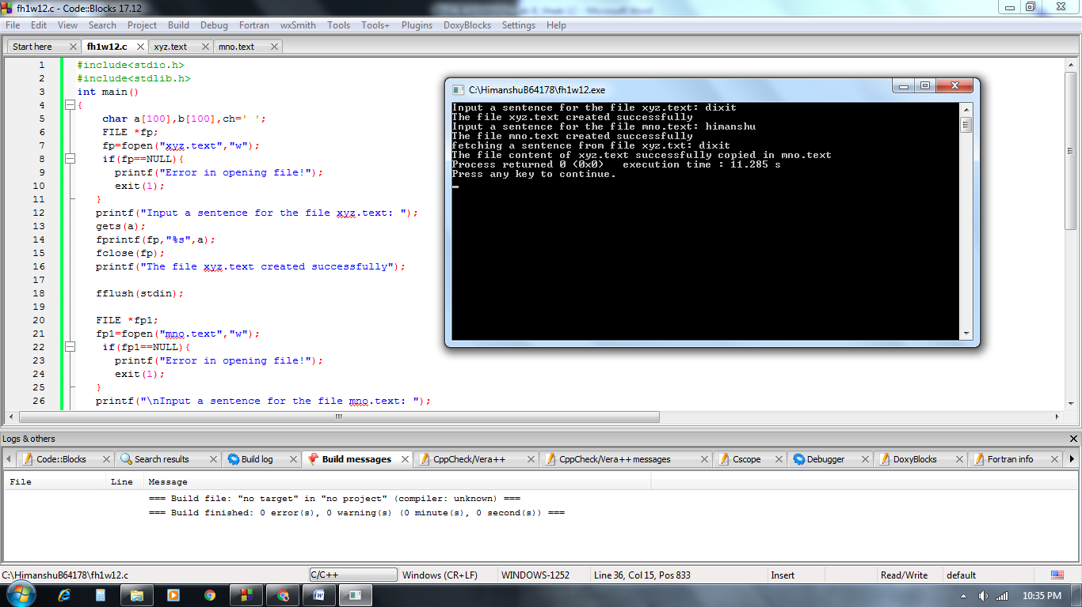

***2.***[*Write a C program to compare two files.*](https://codeforwin.org/2018/02/c-program-compare-two-files.html)

*File 1*

*Learn C programming at Codeforwin.*

*Working with files and directories.*

*File 2*

*Learn C programming at Codeforwin.*

*Working with array and pointers.*

*Output*

*File are not equal.*

*Line: 2, column: 14*

**Solution:**

#include<stdio.h>

#include<stdlib.h>

int main()

{

char a[100],b[100],ch,ch1,c='\n';

int x,y,s=0,l=1;

FILE *fp;

fp=fopen("xyz.text","w");

if(fp==NULL){

printf("Error in opening file!");

exit(1);

}

printf("Input a number of lines u wants to enter in file xyz.text: ");

scanf("%d",&x);

fflush(stdin);

for(int i=0;i<x;i++){

gets(a);

fputs(a,fp);

fflush(stdin);

fputc(c,fp);

}

fclose(fp);

printf("The file xyz.text created successfully");

FILE *fp1;

fp1=fopen("mno.text","w");

if(fp1==NULL){

printf("Error in opening file!");

exit(1);

}

printf("\nInput a number of lines u wants to enter in file mno.text: ");

scanf("%d",&y);

fflush(stdin);

for(int i=0;i<y;i++){

gets(b);

fputs(b,fp1);

fflush(stdin);

fputc(c,fp);

}

fclose(fp1);

printf("The file mno.text created successfully");

fp=fopen("xyz.text","r");

fp1=fopen("mno.text","r");

if(fp==NULL){

printf("Error in opening file!");

exit(1);

}

if(fp1==NULL){

printf("Error in opening file!");

exit(1);

}

ch1 = fgetc(fp1);

while((ch = fgetc(fp)) != EOF){

if(ch1==ch)

{

s++;

}

if(ch == '\n')

{

l++;

s=0;

}

if(ch != ch1)

{

printf("\nFiles are not equals");

printf("\nline : %d , coloumn : %d",l,s+1);

break;

}

ch1 = fgetc(fp1);

}

fclose(fp);

fclose(fp1);

if(ch == EOF && ch == EOF)

printf("\nFiles are equals");

else if(ch == EOF){

printf("\nFiles are not equals");

printf("\nline : %d , coloumn : %d",l,s+1);

}

return 0;

}

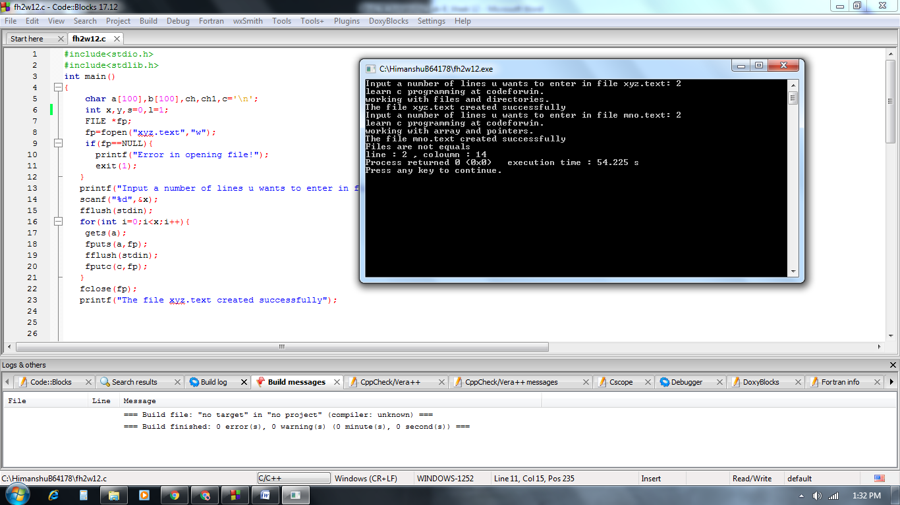

***3.*** *Write a C Program to read student details and store it in file using File Handling*

**Solution:**

#include <stdio.h>

#include <stdlib.h>

int main()

{

char name[20];

char branch[20];

char enroll[20];

FILE *fp;

fp = fopen("record.txt", "w");

if (fp == NULL)

{

printf("Cannot open file /n");

exit(1);

}

printf("Enter in sequence--> name,branch,enroll\n");

gets(name);

gets(branch);

scanf("%s", enroll);

fprintf(fp,"Name = %s\nBranch = %s\nEnroll = %s", name, branch, enroll);

return 0;

}

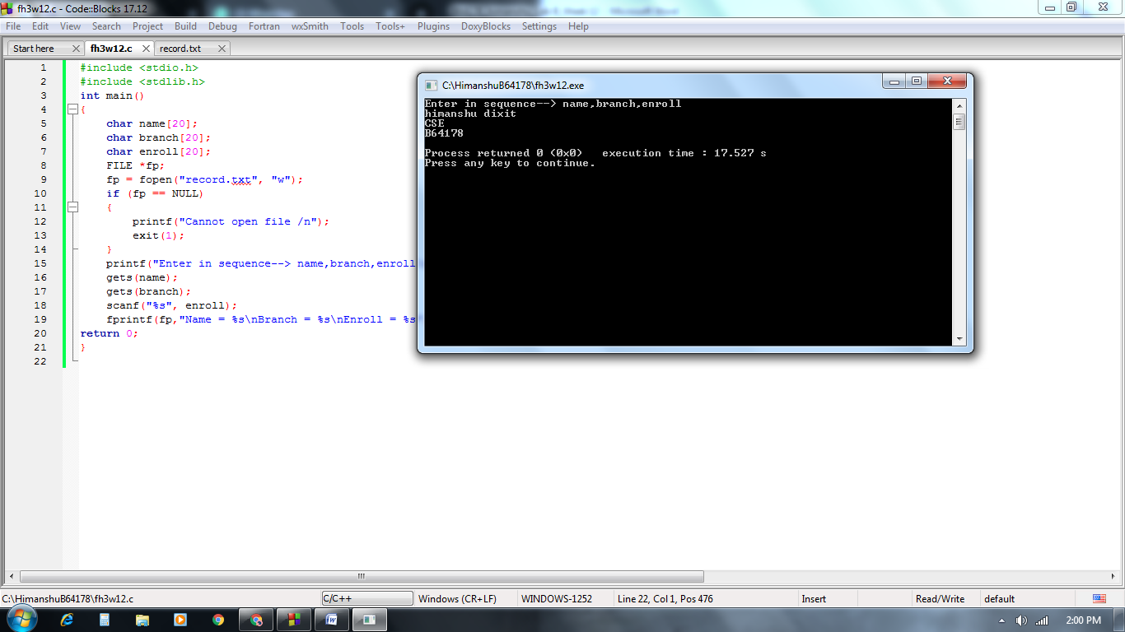

***4.*** *Write a C program that read integers from a file and appends sum to the end in File Handling*

*OUTPUT : :*

*How many numbers? 6*

*Enter numbers in the file:*

*1*

*2*

*3*

*4*

*5*

*6*

*File after append:*

*1 2 3 4 5 6 21*

**Solution:**

#include<stdio.h>

#include<stdlib.h>

int main()

{

int a,n;

printf("How many number : ");

scanf("%d",&n);

FILE *fp;

fp=fopen("sum.text","w");

if(fp == NULL)

{

printf("\ncan't open file");

exit(1);

}

for(int i=0;i<n;i++)

{

scanf("%d",&a);

fprintf(fp,"%d ",a);

}

fclose(fp);

printf("Values are successfully added in file sum.text\n");

printf("\nReading Values from sum.text\n");

fp=fopen("sum.text","a+");

int b,sum=0;

if(fp == NULL)

{

printf("\ncan't open file");

exit(1);

}

for (int i=0; i<n; i++)

{

fscanf(fp,"%d ",&b);

printf("%d\n",b);

sum =sum+b;

}

printf("Sum = %d",sum);

fprintf(fp,"%d",sum);

fclose(fp);

printf("\nSum is successfully aappended in file sum.txt\n");

return 0;

}

